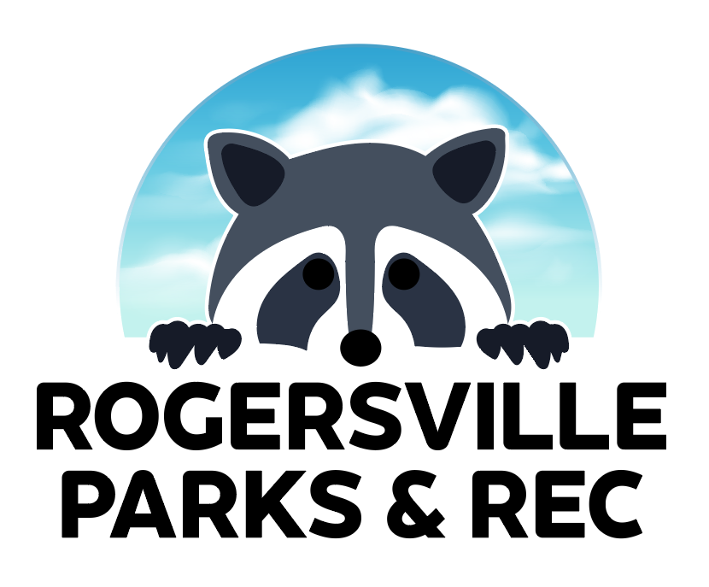
ROGERSVILLE PARKS AND RECREATION
LIABILITY WAIVER

In consideration of your acceptance of this entry, I, as the listed Participant or for my child if listed as the Participant, intending to be legally bound hereby for myself, my heirs and assignees, waive any/all claims for any damages which I and/or my Participant child may have against the City of Rogersville and/or any other sponsors and/or their employees and/or agents for any injuries suffered by me or my Participant child in this event, including those which may be attributed to weather conditions. I attest that I and/or my Participant child are physically fit and have sufficiently trained for the completion of this event. I agree to receive e-mail communications from the City of Rogersville. I give permission for me and/or my Participant child to be photographed or videoed while participating in City of Rogersville activities and for those photos and videos to be used for promotional purposes. I have read the entry information provided and certify me and my Participant child’s compliance by my signature below. If there is an emergency on the racecourse, please call 911.

PARTICIPANT SIGNATURE (IF OVER 18):

X_________________________________________________________________

IF PARTICIPANT UNDER 18, PARENT OR GUARDIAN SIGNATURE:

X__________________________________________________________________

FOR ANY QUESTIONS OR CONCERNS, PLEASE CONTACT THE PARK DIRECTOR AT 417-988-0810 OR KROBERTSON@ROGERSVILLEMO.ORG

