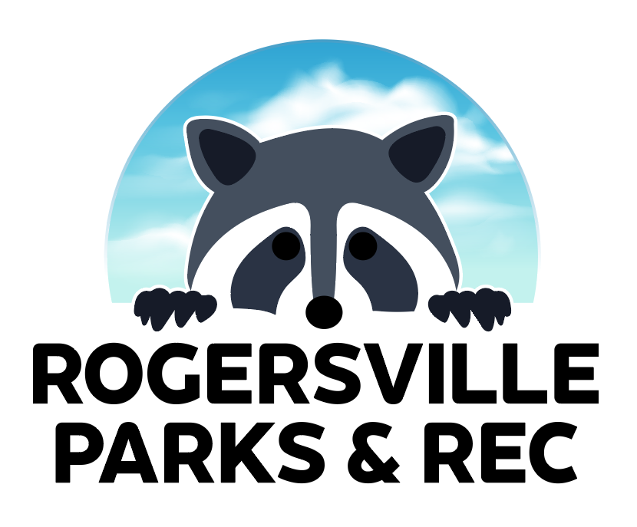
ORGANIZATION PARTNERSHIP FORM (RENTALS)
This form allows for organizations to partner with the Rogersville Parks and Recreation department to provide community services at the park for a reduced fee.
REQUIREMENTS FOR PARTNERSHIP
- Organization must be a non-profit or not-for-profit (OR SHOW PROOF WITH PARK DIRECTOR’S DISCRETION THAT THIS ORGANIZATION DOES NOT MAKE PROFIT)
- Organization must be providing a community service during park rental, including, but not limited to:
  - Free service (haircuts, classes, etc.)
  - Free goods (food, toiletries, etc.)
- Organization must not charge an entry fee to rentals and/or events
- Organization advertising must include Rogersville Parks and Recreation in some capacity (WITH THE DISCRETION OF PARK DIRECTOR)
- Organization must abide by all park policies

ORGANIZATION INFORMATION
ORGANIZATION NAME: _______________________________________________
CONTACT NAME: ____________________________________________________
CONTACT POSITION: _________________________________________________
CONTACT NUMBER: _________________ CONTACT EMAIL: _________________
RENTAL/EVENT PURPOSE: _____________________________________________
CIRCLE ONE: NON-PROFIT NOT-FOR-PROFIT

*PLEASE TURN INTO THE PARK DIRECTOR AT CITY HALL, OR EMAIL TO KROBERTSON@ROGERSVILLEMO.ORG*

