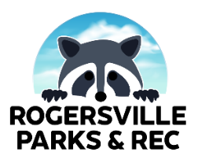
COUNTY LINE ROAD PARK
SPLASH PAD BIRTHDAY PARTY PACKAGES FORM
TODAY’S DATE: __________

DATE REQUESTED:____________ (ONLY AVAILABLE M-F)
TIME SLOT REQUESTED: 11AM-1PM ($50) ___ ; 2PM-4PM ($50) ___ ; 4PM-7PM ($50) ___
BIRTHDAY PARTY FOR: _________________________________________________________

CONTACT NAME: _______________________ CONTACT PHONE NUMBER: ________________
CONTACT EMAIL: _______________________

TYPE OF PIZZA (2 LARGE PIZZAS INCLUDED)
__ CHEESE
__ PEPPERONI
__ SUPREME

TYPE OF SODA (2 2-LITERS INCLUDED)
__ COKE
__ DIET COKE
__ SPRITE

SPECIAL REQUESTS (NOT GUARANTEED): ___________________________________________________

*PLEASE FILL OUT THIS FORM AND RETURN/PAY AT CITY HALL. FOR QUESTIONS OR CONCERNS, CONTACT 417-988-0810 OR EMAIL KROBERTSON@ROGERSVILLEMO.ORG*

