

**City of Rogersville Parks and Recreation**

**YOUTH AND ADULT FLAG FOOTBALL**

**RULES AND REGULATIONS**



**MISSION STATEMENT: The City of Rogersville’s Parks and Recreation Department is dedicated to providing exceptional parks, events, programs, and public service. In doing so, we aid in the well-being and growth of our city. We provide places and services that will help people become their best selves through connection and community.**

**Welcome to the Rogersville Community Park Program**

Our programs strive to bring the community closer together and to have fun while also learning the benefits of sportsmanship, respect, and teamwork. We are excited to add flag football to the list of programs that we offer and hope to make it a considerable success going forward.

We would like to share with parents the rewarding responsibility of helping our youth grow. As parents, you play an important part in creating a positive environment where children can grow, develop, and have fun. Children want to feel good about themselves and want their parents to feel good about them. Participation by parents helps meet this need. Specifically, when you:

* Support your child with praise.
* Attend practices and all games.
* Are aware of the RCP handbook and support it.
* Spend time with your child working on skills learned during practices and games.
* Listen to your child when they talk about their feelings and accomplishments.
* Volunteer in a way that will help the program and your child.

Hopefully, this handbook will be of value to you. If during this program you have a comment or questions, please contact me at 417-988-0810. We would like to know what we are doing well and where we need to continue to improve. We value your input!

See you at the games,

Katie Robertson

Director of Parks and Recreation

**Our Philosophy**

The Rogersville Community Park Philosophy puts participation first and winning second. The following are the basics for The Rogersville Community Park Philosophy:

* Participation- Everyone plays equally
* Fun- Having fun should be the reason for participating in sports
* Fitness- Exercise is important to everyone
* Skills- Emphasizing the fundamentals for learning
* Teamwork- Our focus is placed on cooperation, not competition
* Fair Play- Our focus is on respect and sportsmanship
* Volunteers- Coach participation is essential

**Purpose**

The purpose of The Rogersville City Park Youth Program is to provide our youth an opportunity to participate in various activities and to:

* Have fun
* Strengthen self-confidence
* Make new friends
* Learn sportsmanship, cooperation, and teamwork
* Promote an atmosphere that strengthens family relationships
* Promote an opportunity for individuals to be of service to others through volunteer experiences

**Team and League Organization**

Players are assigned to teams by age; youth league will be 18 and under with players needing to be at least 5 to play, and adult league will be over 18. More specific age breakdowns will be implemented based on the amount of participation and will focus on making each player have a fair chance to compete.

The Rogersville City Park has the final authority over the placement and number of players per team. Teams are encouraged to sign up as a team if applicable.

Team sizes will also be up to the number of participants and teams, but the standard way to play flag football is 5 vs 5 or 7 vs 7. This means teams will consist of the number of players on the field plus 3-6 reserve players to substitute in.

All leagues are designed to give each player an opportunity to work on skills, have fun, and have a basic feeling of success.

Each league will last five weeks.

**Coaches**

All coaches are volunteers and are required to attend at least one preseason meeting.

Coaches are expected to be positive role models and follow The Rogersville Community Park’s Youth Rule Book.

If the Director of Programs feels a coach is not abiding by The Rogersville City Park’s Youth Rule Book, that coach may be replaced.

Each coach is responsible for ensuring their team follows the park rules.

Adult leagues will have more of a team captain rather than a coach who will be responsible for communicating information to the team and making sure everyone follows the rules.

**Flag football Rules**

Our flag football rules will closely follow those that are on nflflag.com for both youth and adult leagues. The main rule of flag football is there is no contact allowed and all “tackles” are to be made by pulling off an opponent's flag from their belt. There shall also no be no tackling, diving, blocking, and screening.

Some other key differences in flag football compared to regular football is that all passes must be forward and beyond the line of scrimmage, no backwards passes or laterals are allowed. The quarterback is not allowed to run with the ball unless it is handed off first or after the defense has begun to rush them. The defense must give the quarterback 7 seconds to make a play before rushing at the quarterback to take their flag. Once a handoff has been made, rushing is allowed immediately.

**Scoring**

In flag football there is no kicking for points and no kickoffs. Each game and half will start with the offense with the ball at their own 5-yard line and will have four downs to try and get to midfield to get a new set of downs. Once the offense gets to midfield, they must get into the endzone within four downs, or the ball goes over to the defense. The ball goes over to the defense if the offense does not get the first down on a 4th down at the current spot of the ball. An offense can choose to “punt” after 3rd down and the other team will get the ball at its own 5-yard line instead of taking over at the spot of the ball. A touchdown is scored by crossing the goal line before your flag is taken and is worth 6 points. After scoring a touchdown a team can go for 1 point from 5 yards out or 2 points from 10 yards out. A defensive safety can be scored by intercepting an extra point attempt and returning it to the opposite end zone for 2 points.

**Game Operations**

There will be two halves that are fifteen minutes each and a brief three-minute halftime. The game is played with a running clock that does not stop unless there is an injury or a team calls a timeout, they get one timeout per half. Timeouts should not take longer than one minute. In the last minute of the second half the running clock goes away and the clock is stopped on out of bounds plays and incompletions. If a game is tied when time expires each team will get one possession in an untimed overtime period to see who can score the most points in their possession, if both teams are still tied the game is over and the outcome is a tie game.

**Players and Positions**

Flag football has the same offensive players as tackle football but minus the offensive linemen. There is still a center who snaps the ball to the quarterback to start the play but instead of blocking the center then becomes another wide receiver who can catch the ball from the quarterback. The quarterback cannot run with the ball and must throw the ball forward or hand the ball off to a running back. Once the ball has been handed off the defense can rush the ball handler, and the quarterback can then become a receiver who is eligible to catch the ball from the running back. Offensive players cannot flag guard, which is preventing the defense from pulling their flag by blocking it with their hand or elbow.

Defensive positions are divided into players who are going to “rush” the ball and players who are going to guard the offense from catching the ball from the quarterback. Rushers must be seven yards behind the line of scrimmage and must wait seven seconds to make a play at taking the flag from the quarterback or until the ball is handed off to rush. Defensive backs are responsible for guarding the wide receivers from catching the ball and must take the flag from the offensive if they get the ball live before they get the line to gain or the end zone. They are not allowed to contact the receivers and must make a play on the ball to be in the legal guarding position. The offense can also not initiate contact to help better make a play on the ball.

**Miscellaneous Rules and Information**

With flag football being a non-contact sport, one of the main penalties is when a player does commit contact in the form of grabbing, holding, blocking, or tackling. When the penalty is on the offense, it is a loss of down and yardage gained on the play is taken away, the offense will start over with one less down to get their line to gain, or if it was on fourth down the ball is turned over on downs. All defensive flag football penalties result in an automatic first down and some are associated with yardage when they happen down the field. The ball is then placed at the spot of the foul. Either side can decline a penalty if they would rather take the result of the play than enforce the penalty. Once the ball is within five yards of the line to gain, either at midfield or the end zone, the offense must throw the ball to pick up the first down and not run to prevent contact in close spaces. There are also no fumbles in flag football, if a ball handler is running and drops the ball it is a dead ball, and a new down is started at the spot the ball was dropped. The field size is 210 ft (70 yards) long by 90 ft (30 yards) wide. Each end zone will take up 10 yards and the playing field is divided into 2 25-yard sections.

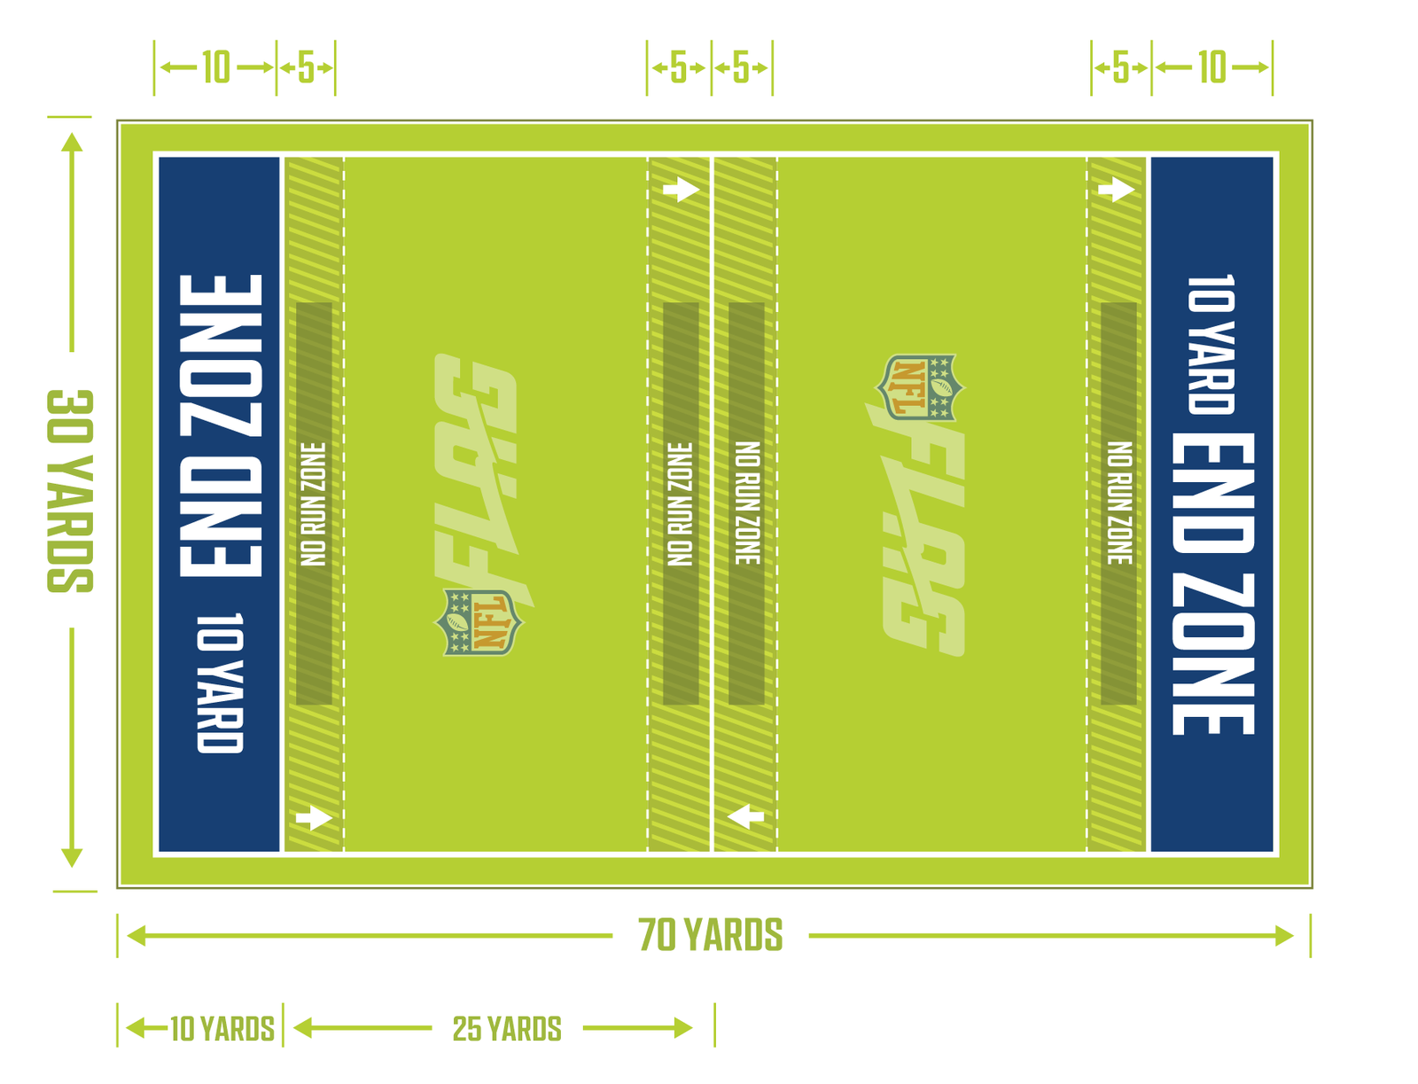

**List of Fouls and Penalties**

*Defensive committed fouls*

|  |  |
| --- | --- |
| Defensive pass interference | Spot foul and automatic first down |
| Holding | +5 yards and automatic first down |
| Stripping the ball | +5 yards and automatic first down |
| Defensive unnecessary roughness | +10 yards and automatic first down |
| Defensive unsportsmanlike conduct | +10 yards and automatic first down |
| Offside / illegal substitution | +5 yards from line of scrimmage and automatic first down |
| Illegal rush (Starting rush from inside 7-yard marker) | +5 yards from line of scrimmage and automatic first down |
| Illegal flag pull (Before the receiver has the ball) | +5 yards from line of scrimmage and automatic first down |
| Roughing the passer | +5 yards from line of scrimmage and automatic first down |
| Taunting | +5 yards from line of scrimmage and automatic first down |

*Offensive committed fouls*

|  |  |
| --- | --- |
| Screening or blocking | -5 yards and loss of down |
| Charging | -5 yards and loss of down |
| Flag Guarding | -5 yards and loss of down |
| Offensive unnecessary roughness | -10 yards and loss of down |
| Offensive unsportsmanlike conduct | -10 yards and loss of down |
| Offside / false start / illegal substitution | -5 yards from line of scrimmage and loss of down |
| Illegal forward pass (Any pass received or lands behind the line of scrimmage or throwing a pass after crossing the line of scrimmage) | -5 yards from line of scrimmage and loss of down |
| Offensive pass interference | -5 yards from line of scrimmage and loss of down |
| Illegal motion (More than one person moving) | -5 yards from line of scrimmage and loss of down |
| Delay of game | -5 yards from line of scrimmage and loss of down |
| Impeding the rusher | -5 yards from line of scrimmage and loss of down |
| Illegal Procedure | -5 yards from line of scrimmage and loss of down |

**Uniforms**

Players may not wear jewelry or hard billed hats. The league will issue out t shirts that must be worn to distinguish which team is which. They will also be given flags with belts that must be worn correctly when on the field. Mouth guards, shin guards and catching gloves are recommended but must be brought by the players.

**GENERAL LEAGUE INFORMATION**

* All players, coaches and spectators will always follow all the rules of the league and conduct a positive attitude to promote good sportsmanship and provide healthy guidance for all players.
* Officials have authority from beginning until the end of the game. Please treat them with respect.
* This program will last five weeks.
* Players must fill out or have parents fill out liability forms before being able to participate in any games.
* Games will only be cancelled or re-scheduled by The Rogersville City Park. The Director of Parks and Recreation will only notify the coaches of cancellations and the offices at City Hall.