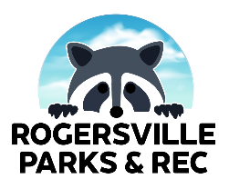
ROGERSVILLE PARKS AND RECREATION
COACH CODE OF CONDUCT

All coach positions are volunteer, and the following rules apply:

_____ I will always be a positive role model, conduct a positive attitude to promote good sportsmanship, and provide healthy guidance for all players.
_____ I will not use profanity, engage in any public confrontation, or open display of anger with the park directors, park staff, umpires, referees, scorekeepers, parents, or players.
_____ I will not use illegal drugs, alcohol, or tobacco during any practice or game.
_____ I will treat all Rogersville Community Park Staff with utmost respect, just as I want to be treated. I will not verbally or physically abuse or intimidate any of the fore-mentioned participants.
_____ I will abide by all age division rules.
_____ I will instruct my team’s parents to cease disruptive behavior if it occurs during a game or practice. I understand if I am not able to curtail the disruptive behavior of a parent the referee/umpire may call the game, and my team will forfeit the game.
_____ I recognize and understand coaching can be rescinded at any time at the will of the Rogersville Parks and Recreation Department and/or leadership.

Date: _____________________

I, ______________________________________, have read the above information. I agree to be a volunteer coach and will abide by this agreement.

