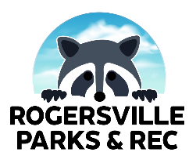
ROGERSVILLE PARKS AND RECREATION
VOLUNTEER CODE OF CONDUCT

The following rules apply to ALL volunteers:

_____ I will always be a positive role model and conduct a positive attitude.
_____ I will not use profanity, engage in any public confrontation, or open display of anger with park management, park staff, other volunteers, or any community member.
_____ I will not use illegal drugs, alcohol, or tobacco during volunteer work.
_____ I will treat all Rogersville Community Park Staff with utmost respect, just as I want to be treated. I will not verbally or physically abuse or intimidate any of the fore-mentioned participants.
_____ I will abide by all park policies.
_____ I recognize and understand volunteering can be rescinded at any time at the will of the Rogersville Parks and Recreation Department and/or leadership.

Date: _____________________

I, ______________________________________, have read the above information. I agree to be a volunteer and will abide by this agreement.

