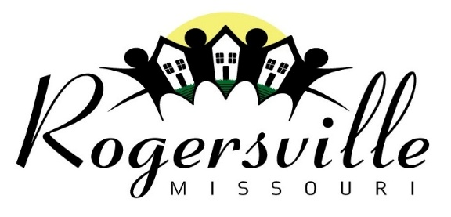
211 East Center St,
P.O. Box 19
Rogersville, Mo 65742
Phone 417-753-2884 Fax 417-753-2846

July 10, 2026

To: Marshfield Mail
From: Glenda Stegner, City Clerk
RE: Publication of Notice

Please publish the following public notice in the next copy of the South County Mail:

The City of Rogersville is requesting quotations from qualified vendors for the purpose of providing the following software and support service:

SACADA/RTU Software and Support

Specifications for the vendors is available at Rogersville City Hall and can be obtained by contacting the Public Works Direct at 417-753-2884, extension 7. This request for proposal process is open until 12:00 p.m. Friday, July 31, 2026.

