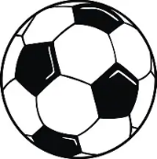

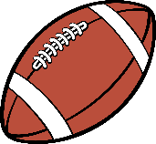
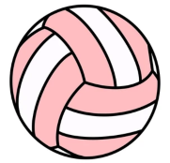
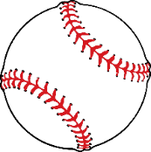

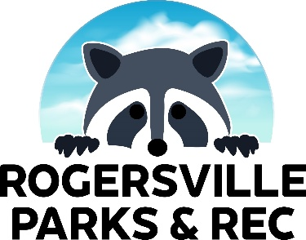

2027 SPONSORSHIP PACKAGES
Team Shirt Sponsorships:
- $150 for black/white logo on back of team shirts for one sports season
- $600 for black/white logo on back of team shirts for all sports seasons – We currently have 6 seasons with the possibility of 8 depending on registration numbers

Sign / Banner Sponsorships:
- $500 for a 3’x5’ metal sign with your full color logo to be displayed year-round at the park and visible during spring soccer, summer baseball, and fall soccer
- $250 for a 2’x3’ vinyl banner with your full color logo to be displayed during basketball and volleyball games

Sports Fanatic Sponsorships:
- $2000 for the following:
  - Logo on back of shirts for all sports seasons
  - Logo on metal sign displayed at the park year-round
  - Logo on vinyl banner displayed during basketball and volleyball games
  - Monthly recognition and a link to your business on the Rogersville Parks Facebook page
Contact Alicia Inmon at 417-988-0810 or ainmon@rogersvillemo.org

